Quiet Woods Counseling, LLC
Anne Meyers, MA, NCC, Registered Psychotherapist
1518 Main Street, Suite 103
Louisville, CO 80027
Phone: 303-518-1335

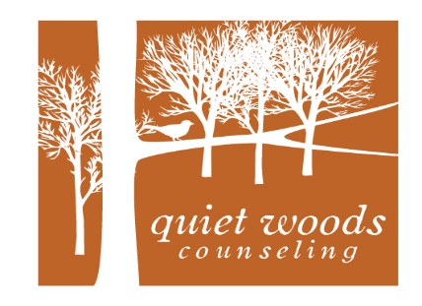

Child and family Intake Form

Demographic Information:
Parent/Guardian 1: | Date:
Date of Birth: | Relationship Status:
Age:
Gender: | Ethnicity:
Preferred Phone #: | Is it ok to leave a message at this number? Y / N
Alternate Phone #: | Is it ok to leave a message at this number? Y / N
Mailing Address:
E-mail Address:
Parent/Guardian 2: | Date:
Date of Birth: | Relationship Status:
Age:
Gender: | Ethnicity:
Preferred Phone #: | Is it ok to leave a message at this number? Y / N
Alternate Phone#: | Is it ok to leave a message at this number? Y / N
Mailing Address:
E-mail Address:
Emergency Contact Name #1: | Relationship:
Phone #: | Address:
Emergency Contact Name #2: | Relationship:
Phone #: | Address:

Please list names and provide information for all children/dependents:

Name | Birthdate | Age | Gender | Ethnicity | Grade  Level | Address

Medical Information:

Is anyone in your family under a doctor’s care? ___ If so, list family member and doctor: __________________
________________________________________________________________________________________Reason for doctor’s care: ___________________________________________________________________
________________________________________________________________________________________
Hospitalizations and reasons: ________________________________________________________________
________________________________________________________________________________________________________________________________________________________________________________
Has anyone in your family ever been hospitalized for a mental illness? ______ If so, list family member and reason: _________________________________________________________________________________
________________________________________________________________________________________________________________________________________________________________________________________________________________________________________________________________________
Has anyone in your family ever suffered from an eating disorder, such as bulimia, anorexia or obesity? ______

If so, provide name of family member(s) and describe: ____________________________________________

________________________________________________________________________________________________________________________________________________________________________________

Please list any past or current major events involving abuse, trauma, suicide, loss, violence, car accidents, surgeries, or any event that was overwhelming to you, your partner, or your family members: ______________

________________________________________________________________________________________________________________________________________________________________________________
________________________________________________________________________________________

Please list medications you and/or family members are currently taking, or have taken during the past 6 months:

Name | Medications

General Information:

How did you hear about Quiet Woods Counseling, LLC? ___________________________________________
Reason for seeking counseling: ______________________________________________________________
________________________________________________________________________________________
________________________________________________________________________________________

Have you or any of your family members had previous counseling experience? Y/N
If so, please list reason for seeking counseling and overall experience: _______________________________
________________________________________________________________________________________
________________________________________________________________________________________
________________________________________________________________________________________
________________________________________________________________________________________
________________________________________________________________________________________

Is there any information related to your culture or identity (such as religion, sexual orientation, etc.) that you would like to share?
________________________________________________________________________________________
________________________________________________________________________________________
________________________________________________________________________________________

Are there any past or current issues with substance or alcohol use/abuse? If so, please describe: ________________________________________________________________________________________
________________________________________________________________________________________________________________________________________________________________________________

Have the police or social services ever been involved with your family? If so, please describe: ________________________________________________________________________________________
________________________________________________________________________________________________________________________________________________________________________________

Does anyone in your family have any past or current legal actions or involvement? If so, please describe: ________________________________________________________________________________________
________________________________________________________________________________________________________________________________________________________________________________

What are the main strengths of you, your family, and/or your relationship with your partner?_______________ ________________________________________________________________________________________________________________________________________________________________________________________________________________________________________________________________________________________________________________________________________________________________

Do you have people in your lives that are a support to you, your family, or your relationship? Please list and describe: ________________________________________________________________________________
________________________________________________________________________________________________________________________________________________________________________________________________________________________________________________________________________

Are there any other concerns or issues that you would like to share? ________________________________________________________________________________________________________________________________________________________________________________________________________________________________________________________________________________________________________________________________________________________________________________________________________________________________________________________

By signing, I affirm that the above information is correct to the best of my knowledge. I understand that if I share information regarding abuse and/or neglect, that the therapist may be obligated to report this information.

Client Signature ________________________________________________________ Date ______________

Client Signature ________________________________________________________ Date ______________

Therapist Signature _____________________________________________________ Date ______________

